A LAB MANUAL
On

Data Science and Big Data Analytics
(III-B.Tech. II–Semester)
Course Code: 24CSPC46

Submitted to
DEPARTMENT OF COMPUTER SCIENCE & ENGINEERING (DATASCIENCE)

By

Mr. M. Raj Kumar
(Assistant Professor, Dept.of CSE(DS))



CMR INSTITUTE OF TECHNOLOGY

(UGC AUTONOMOUS)
Kandlakoya (V) , Medchal Road,Hyderabad–501401

Syllabus
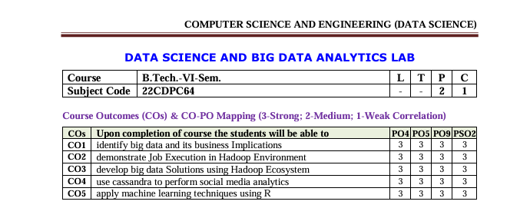
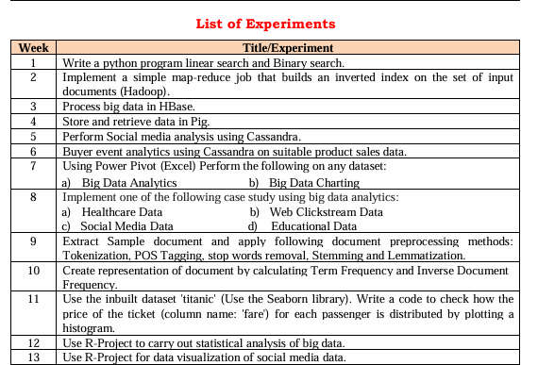

Experiment-1

Aim: Write a python program linear search and Binary search.
Require Software& Tools: anaconda (jpyter note book)
Procedure:

Step-1: open any python IDE write the program

Step-2: Linear Search:

Step-3: Iterate through each element.

Step-4: Compare with the target.

Step-5: If found, return the index, else return -1.

Step-6: run the program

Step-7: Result

Binary Search:

Step-1: Sort the array (if needed).

Step-2: Initialize low and high pointers

Step-3: Find the middle element and compare with the target

Step-4: Adjust the pointers (low or high) based on the comparison

Step-5: Repeat until the target is found or the pointers cross

Step-6: Return the index if found, else return -1

Step-7: Run the program write the result.

SOURCECODE:

Linear search

l=list()

n=int(input("Enter number of elements to be inserted into list:"))

print("Enter",n," Values")

for i in range(n):

l.append(int(input()))

s=int(input("Enter element to be searched"))

for i in range(len(l)):

if l[i]==s:

print(s," is found at position", i+1)

break

else:

print("Element is not found")
Binary search:
l=list()
n=int(input("enter number of elememts"))
print("enter",n, "values")
for i in range(n):
l.append(int(input()))
l.sort()
s=int(input("enter element to be searched"))
low=0
high=len(l)-1
found=False
while low<=high:
mid=(low+high) // 2
if l[mid] == s:
print(s," is found at position ",mid+1)
found=True
break
elif l[mid]<s:
low=mid+1
else:
high=mid-1
if not found:
print(s," is not found in list")

Out put:

Linear search
Enter number of elements to be inserted into list: 5
Enter 5 Values
11
12
30
45
22
Enter element to be searched 30
30 is found at position 3
Binary search:
enter number of elememts 5
enter 5 values
10
25
30
40
50
enter element to be searched 25
25 is found at position 2

Experiment-2
Aim: Implement a simple map-reduce job that builds an inverted index on the set of input documents (Hadoop).
Require Software& Tools: (Hadoop,java,linux,intellij)

1.open vm ware start ubunt then open terminal
2.hadoop version
3.java –version
4.start-all.sh
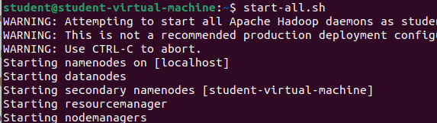

5.jps
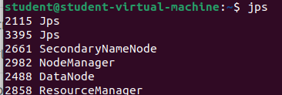
6.hadoop-3.4.0/bin/hdfs namenode –format
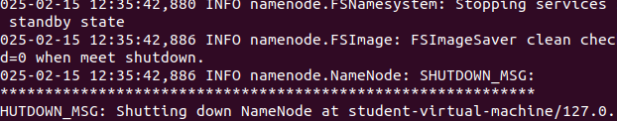
7.start-all.sh

8.open browser http://localhost:9870
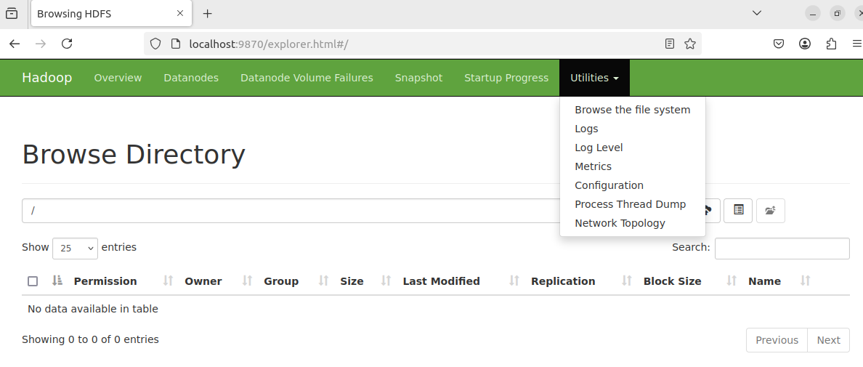
9.open intellij idea click on new project give the name of the project

10.select maven goto advance give the group id name org.dsbda
11.remove main class
12.create dependencies in org.dsbda copy the dependencies code from the git hub
github.com/ rishikumar1992/DSBDA-LAB
13.go to maven click on the project name reload all projects
14.create the 3 java classes WC_Mapper ,Reducer,Runner copy the code from git hub
15.create jar file ---> click on maven clean enter and maven install
16.target folder will be created which contains jar file
17.goto ubuntu tewrminal create the text file input2.txt
18.nano sample.txt
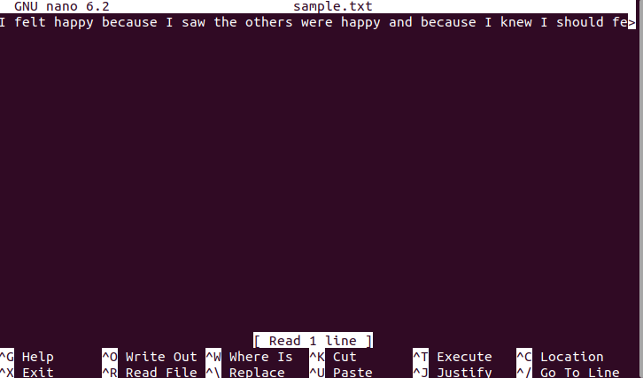
19.write some text with repeated words
20.cntrl+o enter cntrl+x
21.cat input.txt
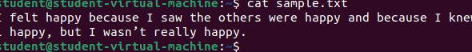
22.create the folder on the localhost hadoop fs -mkdir /input2
23.hadoop fs -put sample.txt /input2
24.back to the local host check the file system
25.back to the intellij go to terminal hadoop jar target/week2-1.0-SNAPSHOT.jar org.dsbda.WC_Runner /input2/input2.txt /output2
26.back to the local host check the file system
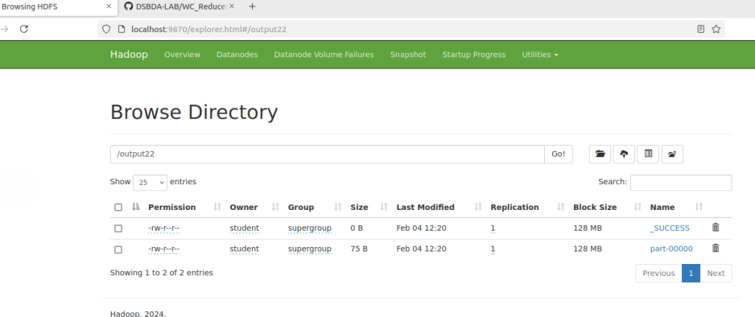
27.click on output2 file
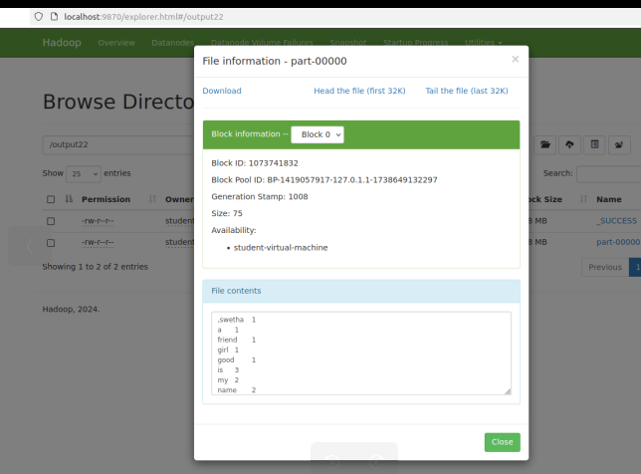
28.back to the main terminal
29.hadoop fs -cat /output2/part-00000
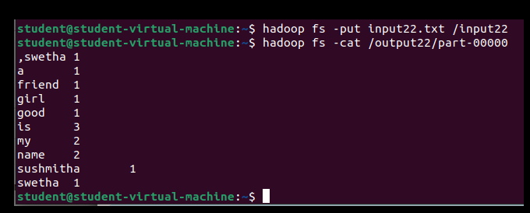

Experiment-3

Aim: To create table and process the big data in Hbase.
Require Software& Tools: Hadoop in Ubuntu, VM ware work station, Hbase
Installation steps for hbase
1.download hbase from apache website(https://dlcdn.apache.org/hbase/2.6.1/hbase-2.6.1-bin.tar.gz)St 2. Place the downloaded file into home folder
hbase-1.1.2-bin.tar.gz in /home
3.Unzip it by executing command $tar -xvf hbase-1.1.2-bin.tar.gz.
It will unzip the contents, and it will create hbase-1.1.2 in the location /home
4.Open hbase-env.sh(to open this go to home/hadoop-2.6.1/conf right click on conf open with terminal)
5.in terminal enter the command: gedit hbase-env.sh
6.Open hbase-env.sh as above and mention JAVA_HOME path in the location.
export JAVA_HOME=/usr/lib/jvm/java-8-openjdk-amd64 (save and close the file)
7.Open ~/.bashrc file(gedit ~/.bashrc )and mention HBASE_HOME path as shown in below
export HBASE_HOME=/home/student/hbase-2.6.1
export PATH=$PATH:$HBASE_HOME/bin(save and close the file)
8. Add properties in the file
Open hbase-site.xml(gedit hbase-site.xml) and place the following properties inside the file
<property>

<name>hbase.rootdir</name>

<value>file:///home/student/hbase-2.6.1</value>

</property>
<property>

<name>hbase.zookeeper.property.dataDir</name>

<value>/home/student/hbase-2.6.1/zookeeper</value>

</property>
(save and close the file)
Here we are placing two properties
- One for HBase root directory and
- Second one for data directory correspond to ZooKeeper.
All HMaster and ZooKeeper activities point out to this hbase-site.xml.
9.close the terminal and go to home/hbase-2.6.1/bin open with terminal
10 type the following commands
a.start-hbase.sh
b.jps
c.hbase shell

Experiment:
1.Creating table in hbase
create ‘customer’,’customer_info’,’customer_details’
output: Creating table customer with column families: [customer_info, customer_details] 0 row(s) in 0.1230 seconds
2.To list the tables in hbase: list
Output:
scss
Copy
TABLE
customer
1 row(s) in 0.0100 seconds

3.To insert values into table:
put ‘customer’,’1’,’customer_info:name’,’sita’
put ‘customer’,’1’,’customer_details:mobile’,’9999999999’
4. To display the contents of the table
get ‘customer’,’1’
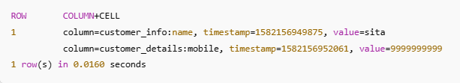
5.To insert other values into table:
put ‘customer’,’1’,’customer_info:age’,’25’
put ‘customer’,’1’,’customer_details:email’,’sita@gmail.com’
6. To display the contents of the table
get ‘customer’,’1’
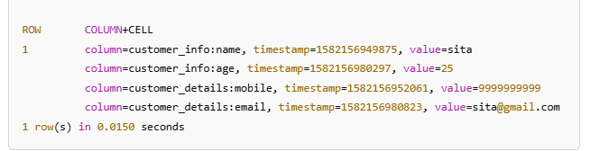
7. To insert other row
put ‘customer’,’2’,’customer_info:name’,’rama’
put ‘customer’,’2’,’customer_details:mobile’,’9898999999’
put ‘customer’,’2’,’customer_info:age’,’28’
put ‘customer’,’2’,’customer_details:email’,’rama@gmail.com’
8.To update the details
put 'customer', '1', '’customer _info:name', 'John' # Update name
put 'customer', '1', '’customer _info:age', '31' # Update age
scan customer;
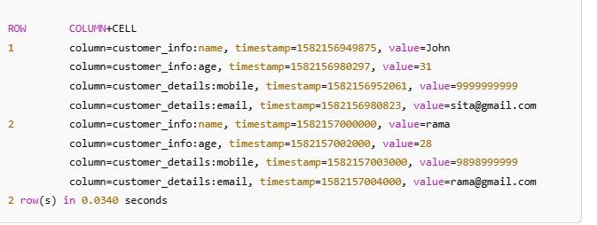
9. Delete an entire row (all columns) from the table:
deleteall 'customer', '1'
10. Delete a specific column from a row:
delete 'customer', '1', 'customer_details:mobile’

Experiment-4

Aim: Store and retrieve data in Pig.

Require Software& Tools: Hadoop in Ubuntu,apache Pig(0.17.0)
Procedure:
- Download Apache Pig:

First of all, download the latest version of Apache Pig from the following website − https://pig.apache.org/

Open the homepage of Apache Pig website. Under the section News, click on the link release page,click on Download a release now
Click on pig-0.16.0/

Click on pig-0.16.0.tar.gz

Install Apache Pig

Step 1:
Create a directory with the name Pig in the same directory where the installation directories of Hadoop, Java, and other software were installed.
$mkdir pig

Step 2:
Extract the downloaded tar files as shown below.
cd Downloads/
$ tar zxvf pig-0.16.0.tar.gz

Step 3:
Move the content of pig-0.15.0.tar.gz file to the Pig directory created earlier as shown below.
$ mv pig-0.16.0.tar.gz/* /home/Pig/

Configure Apache Pig
After installing Apache Pig, we have to configure it. To configure, we need to edit two files − bashrc and pig.properties
$pig -h properties
Open bashrc
$gedit ~/.bashrc
add this path
export PIG_HOME=/home/student/pig
export PATH=$PATH:$PIG_HOME/bin
export PIG_CLASSPATH=$HADOOP_HOME/conf
verifying installation
step1:open vm ware workstation and start ubuntu
Step2:click on home then go to the pig folder then select bin folder and right click open in terminal
Step3: check the pig version :$pig –version
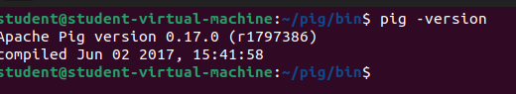
Step4:Create a text file
Step5:gedit studata.txt write the some text
Data
Krishna,1,22,cse
rani,2,21,csd
raju,3,22,aiml
sita,2,20,cse
rama,1,23,csd
hari,1,22,aiml
vishnu,3,25,cse
laxmi,3,20,csd
vishva,2,22,aiml
teja,4,23,cse
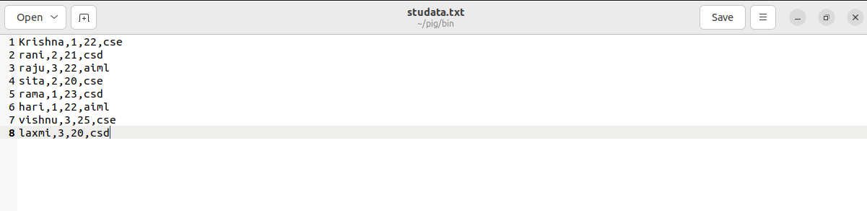
step6:save and close
step7:start pig: pig –x local
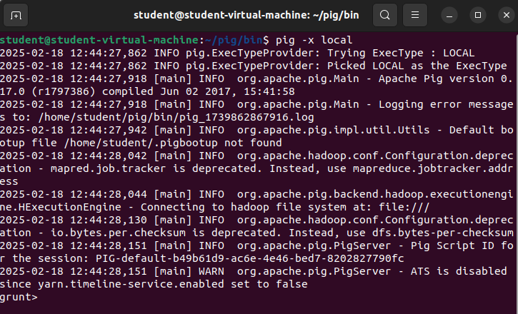
step8:To load data from local system
mydata = LOAD '/home/student/pig/bin/studata.txt' USING PigStorage(',') AS (name:chararray, rollnumber:int, age:int, class:chararray);
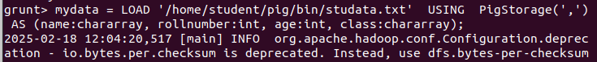
step9:To dump the loaded data: dump mydata;
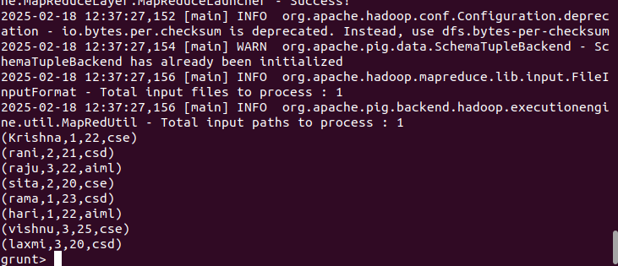
step10:to describe the data :describe mydata;
step11:Query 1: Grouping All Records Class.
(This command will group all the records by the column Class)

Step12:grunt> studentsbranch = GROUP mydata BY class;
To see the output
Step13: dump studentsbranch;
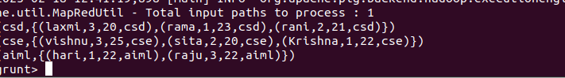
Step14: To store data into local system
STORE studentsbranch INTO 'result.txt' USING PigStorage(',');
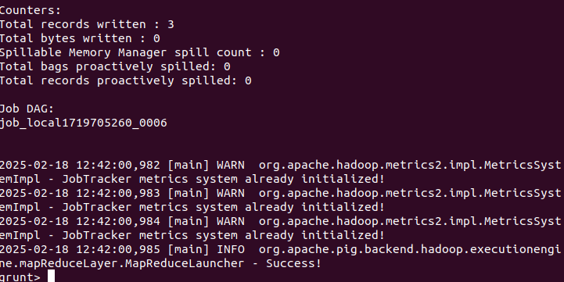
Step15: see the output in bin folder select the output txt the open part-r-00000
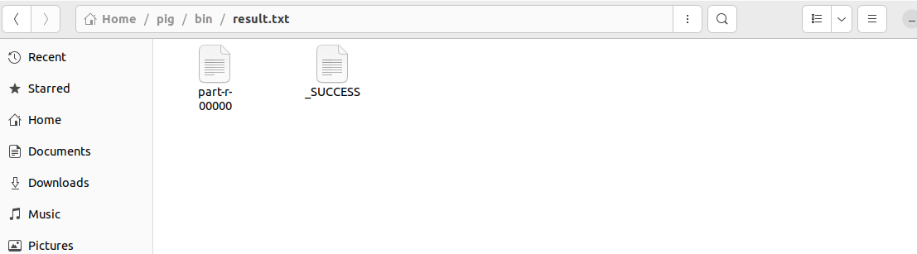
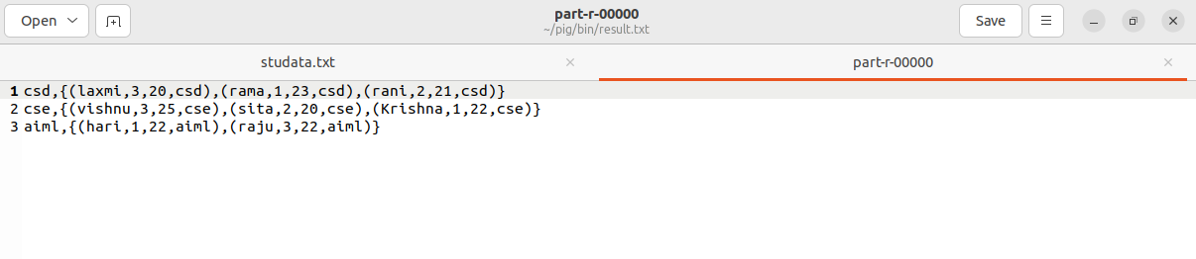

Experiment-5
Aim: Perform Social media analysis using Cassandra.
Require Software& Tools: Hadoop in Ubuntu, VM ware work station,Cassandra
Procedure: below imp queries of cassandra
Step1: cqlsh> CAPTURE '/home/hadoop/CassandraProgs/Outputfile'
Step2: cqlsh:tutorialspoint> select * from emp;
Step3: cqlsh:tutorialspoint> capture off;
Step4: cqlsh:tutorialspoint> CONSISTENCY
Step5: cqlsh:tutorialspoint> COPY emp (emp_id, emp_city, emp_name, emp_phone,emp_sal)
TO ‘myfile’;
Step6: cqlsh:tutorialspoint> describe cluster;
Step7: cqlsh:tutorialspoint> describe keyspaces;
Step8: cqlsh:tutorialspoint> describe table emp;
Step9: cqlsh:tutorialspoint> describe type card_details;
Step10: cqlsh:tutorialspoint> DESCRIBE TYPES;
Step11: cqlsh:tutorialspoint> expand on;
cqlsh:tutorialspoint> select * from emp;
cqlsh:tutorialspoint> expand off;
Step12: cqlsh:tutorialspoint> source '/home/hadoop/CassandraProgs/inputfile';

SOURCECODE AND OUTPUT:
Performing social media analysis using Apache Cassandra involves storing and processing large volumes of social media data efficiently. Cassandra is a distributed NoSQL database that is highly scalable and fault-tolerant, which makes it ideal for storing social media data like posts, comments, likes, and user interactions.
Let's go through a step-by-step example of how to perform social media analysis using Cassandra.

Step 1: Set Up Cassandra
Before we start, ensure that Apache Cassandra is installed and running on your system. You can download it from the official website or use Docker to quickly set up a Cassandra container.

docker run --name cassandra -d -p 9042:9042 cassandra:latest
This will start a Cassandra instance that listens on port 9042, the default port for CQL (Cassandra Query Language).

Step 2: Design the Data Model

For social media analysis, we need to design an appropriate data model. Social media data generally includes posts, comments, likes, and user data. In Cassandra, data modeling is key, as it is optimized for fast writes and specific query patterns.
Let’s consider a simplified example of the following social media data:
- User Table: User profile details (e.g., user_id, name, email).
- Posts Table: Posts by users (e.g., post_id, user_id, content, timestamp).
- Comments Table: Comments on posts (e.g., comment_id, post_id, user_id, content, timestamp).
- Likes Table: Likes on posts (e.g., post_id, user_id, timestamp).

Step 3: Create Keyspaces and Tables in Cassandra
Once Cassandra is set up, we can create a keyspace and the necessary tables for storing social media data.

Create Keyspace
In Cassandra, a keyspace is similar to a database in relational systems. We can create a keyspace with the following command in CQL (Cassandra Query Language):
CREATE KEYSPACE social_media
WITH replication = {'class': 'SimpleStrategy', 'replication_factor': 1};
his command creates a keyspace named social_media with a replication factor of 1. In production, you might want to adjust the replication factor based on fault tolerance needs.

Create Tables
Now, let's create the necessary tables to store social media data.
Create User Table:
CREATE TABLE social_media.users (
user_id UUID PRIMARY KEY,
name TEXT,
email TEXT
);
Create Posts Table:
CREATE TABLE social_media.posts (
post_id UUID PRIMARY KEY,
user_id UUID,
content TEXT,
timestamp TIMESTAMP
);
Create Comments Table:
CREATE TABLE social_media.comments (
comment_id UUID PRIMARY KEY,
post_id UUID,
user_id UUID,
content TEXT,
timestamp TIMESTAMP
);

Create Likes Table:
CREATE TABLE social_media.likes (
post_id UUID,
user_id UUID,
timestamp TIMESTAMP,
PRIMARY KEY (post_id, user_id)
);

Step 4: Insert Data
Now that the tables are created, let’s insert some sample data into them.
Insert Users:
INSERT INTO social_media.users (user_id, name, email) VALUES (uuid(), 'Alice', 'alice@example.com');
INSERT INTO social_media.users (user_id, name, email) VALUES (uuid(), 'Bob', 'bob@example.com');
Insert Posts:
INSERT INTO social_media.posts (post_id, user_id, content, timestamp) VALUES (uuid(), <user_id_Alice>, 'This is Alice\'s first post!', toTimestamp(now()));
INSERT INTO social_media.posts (post_id, user_id, content, timestamp) VALUES (uuid(), <user_id_Bob>, 'This is Bob\'s first post!', toTimestamp(now()));
Insert Comments:
INSERT INTO social_media.comments (comment_id, post_id, user_id, content, timestamp) VALUES (uuid(), <post_id_1>, <user_id_Bob>, 'Great post, Alice!', toTimestamp(now()));
INSERT INTO social_media.comments (comment_id, post_id, user_id, content, timestamp) VALUES (uuid(), <post_id_2>, <user_id_Alice>, 'Thanks for the post, Bob!', toTimestamp(now()));
Insert Likes:
INSERT INTO social_media.likes (post_id, user_id, timestamp) VALUES (<post_id_1>, <user_id_Bob>, toTimestamp(now()));
INSERT INTO social_media.likes (post_id, user_id, timestamp) VALUES (<post_id_2>, <user_id_Alice>, toTimestamp(now()));
Get Posts by User:
SELECT * FROM social_media.posts WHERE user_id = <user_id_Alice>;
This will return all posts made by Alice.
Get Comments on a Post:
SELECT * FROM social_media.comments WHERE post_id = <post_id_1>;
This will return all comments for a particular post.
Get Likes on a Post:
SELECT * FROM social_media.likes WHERE post_id = <post_id_1>;
This will return all users who liked a particular post.

Advanced Analysis
For more complex analysis, such as finding the most liked posts or analyzing the sentiment of comments, you can use additional tools alongside Cassandra.
- Apache Spark: You can integrate Apache Spark with Cassandra for large-scale data processing and advanced analytics, such as aggregations, sentiment analysis, or recommendations.
- Machine Learning Models: You can apply machine learning algorithms to analyze user behavior, predict trends, or classify posts/comments.
For example, to calculate the most liked posts:
SELECT post_id, COUNT(user_id) AS likes_count
FROM social_media.likes
GROUP BY post_id
ORDER BY likes_count DESC;
However, as Cassandra doesn’t support complex aggregation queries like SQL databases, tools like Apache Spark are typically used to process the data and perform such analysis.

Visualize the Results
Once the data has been queried and processed, you can visualize the results using tools like:
- Apache Superset
- Tableau
- Power BI
These tools can be connected to Cassandra or Apache Spark to create dashboards for monitoring social media trends, user engagement, and more.

Experiment-6
Aim: To perform the buyer event analysis using Cassandra on sales data

Require Software& Tools: Hadoop in Ubuntu, VM ware work station, Cassandra

Procedure: Step 1: Setting Up Apache Cassandra
Before starting with the analysis, ensure that you have Apache Cassandra installed and running. If you don't have it installed, download and follow the installation guide.

Step 2: Data Modeling for Sales Data
Sales data typically includes information such as:
- Sale ID (Unique identifier for the sale)
- Buyer ID (Unique identifier for the buyer)
- Item ID (Product purchased)
- Quantity (Amount of the product bought)
- Price (Price of the product)
- Timestamp (When the sale occurred)
For the purpose of analysis, you might want to store the data in a way that allows you to quickly query buyer behavior.

Example Schema Design:
In Cassandra, it’s important to design your tables based on the queries you intend to perform. For buyer event analysis, you might want to track the sales per buyer or analyze buyer activity over time.

Table 1: sales_by_buyer
This table will store sales data for each buyer.
CREATE TABLE sales_by_buyer (
buyer_id UUID,
sale_id UUID,
item_id UUID,
quantity INT,
price DECIMAL,
timestamp TIMESTAMP,
PRIMARY KEY (buyer_id, timestamp, sale_id)
);

Explanation:
- buyer_id: Partition key, ensures that data is grouped by buyer.
- timestamp: Clustering key to store sales chronologically per buyer.
- sale_id: Uniquely identifies each sale for a buyer.

Table 2: sales_by_item
This table stores sales data per item, allowing you to track item-specific buyer events.
CREATE TABLE sales_by_item (
item_id UUID,
sale_id UUID,
buyer_id UUID,
quantity INT,
price DECIMAL,
timestamp TIMESTAMP,
PRIMARY KEY (item_id, timestamp, sale_id)
);

Step 3: Insert Sales Data into Cassandra
Once your tables are set up, you can insert sample sales data into the tables using INSERT INTO.

Sample Query to Insert Data:
INSERT INTO sales_by_buyer (buyer_id, sale_id, item_id, quantity, price, timestamp)
VALUES (uuid(), uuid(), uuid(), 2, 100.50, toTimestamp(now()));

INSERT INTO sales_by_item (item_id, sale_id, buyer_id, quantity, price, timestamp)
VALUES (uuid(), uuid(), uuid(), 2, 100.50, toTimestamp(now()));
You can repeat this process to insert multiple rows.

Step 4: Perform Analysis Queries

1. Retrieve Total Sales per Buyer
You can query the sales_by_buyer table to get the total sales for a specific buyer.
SELECT buyer_id, SUM(quantity * price) AS total_spent
FROM sales_by_buyer
WHERE buyer_id = <specific_buyer_id>
GROUP BY buyer_id;

2. Find All Purchases for a Specific Buyer
If you want to analyze the buying pattern of a specific buyer, you can retrieve all of their purchases.
SELECT sale_id, item_id, quantity, price, timestamp
FROM sales_by_buyer
WHERE buyer_id = <specific_buyer_id>;

3. Find Popular Items
To find out which items are being bought the most across all buyers, you can query the sales_by_item table.
SELECT item_id, SUM(quantity) AS total_sold
FROM sales_by_item
GROUP BY item_id
ORDER BY total_sold DESC;

4. Find Buyers Who Purchased a Specific Item
If you’re interested in finding which buyers bought a specific item, you can query the sales_by_item table.
SELECT buyer_id, sale_id, quantity, price, timestamp
FROM sales_by_item
WHERE item_id = <specific_item_id>;

Step 5: Analyze Buyer Events Using Aggregations
After querying the data, you may want to perform aggregations on the results.

1. Buyer Retention Analysis
You can group buyers by their last purchase timestamp to check for repeat buyers. For example, buyers who made a purchase within the last 30 days are considered retained.
SELECT buyer_id, MAX(timestamp) AS last_purchase
FROM sales_by_buyer
GROUP BY buyer_id
HAVING MAX(timestamp) > toTimestamp(now()) - 30;

2. Frequent Buyers
Find the top N buyers who have made the most purchases:
SELECT buyer_id, COUNT(sale_id) AS purchase_count
FROM sales_by_buyer
GROUP BY buyer_id
ORDER BY purchase_count DESC
LIMIT 10;

3. Item Purchase Analysis
Analyze which buyers tend to buy specific combinations of items:
SELECT buyer_id, item_id, SUM(quantity) AS total_quantity
FROM sales_by_buyer
WHERE item_id IN (<item_id1>, <item_id2>)
GROUP BY buyer_id, item_id;

Step 6: Visualize the Data
While Cassandra is great for handling large-scale data, you may want to visualize the results using a tool like Apache Spark with Cassandra Connector or use an external tool like Tableau or Grafana for better insights.

Example Visualization:
- Total spending by each buyer could be visualized as a bar chart.
- Most purchased items could be visualized as a pie chart.
- Buyer retention could be visualized as a line graph over time.

Step 7: Optimization & Scaling
For large-scale data, consider:
- Data Modeling: Proper design of partition keys and clustering keys ensures efficient querying.
- Indexing: Use secondary indexes carefully as they may not be ideal for large datasets. Consider using Materialized Views or Search in Elasticsearch for more complex querying.

Step 8: Output & Results
When querying the tables as shown in the previous steps, you will get output that looks like this (the exact results depend on your inserted data):
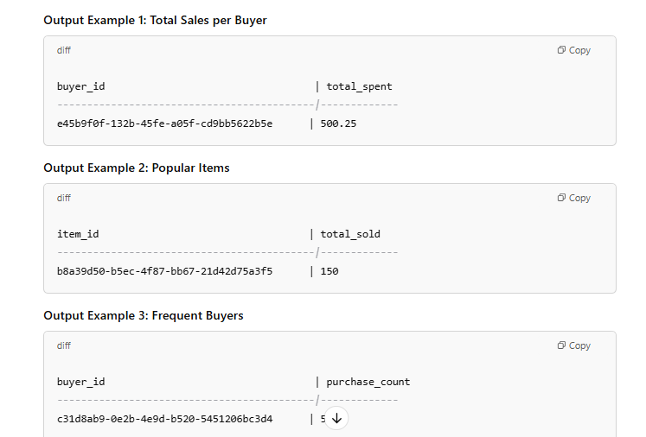

Experiment-7
Aim: Using Power Pivot (Excel) Perform the following on any dataset:
a) Big Data Analytics b) Big Data Charting

Require Software& Tools: Ubuntu, VM ware work station, Libre office Calc
Procedure:
1. Open Ubuntu
2.start libra office calc
3. got to file -> open -> load data to libra office calc
4. Formatting date using function
5. Go to cell D -> right click and inser column before
New column will be created
Name it as “Formatted Dates”
6. Formula for converting date dd/mm/yyyy to date month year
=TEXT(C2,”d mmmm yyyy”)
7. Upon cell D -> right click and insert column after
New column will be created
Name it as “Year”
8.Select E column -> data -> sort ascending then click on extend selection an click on ok
Data Analysis:
- Which category of products with the highest sales?
- Which sub-category has the highest sales?
- Which region drives the most sales to this super store?

Pivot Tables and Charts:
- Which category of products with the highest sales?
  - Select data tab and go to pivot table (insert or edit) select source current selection then click on ok
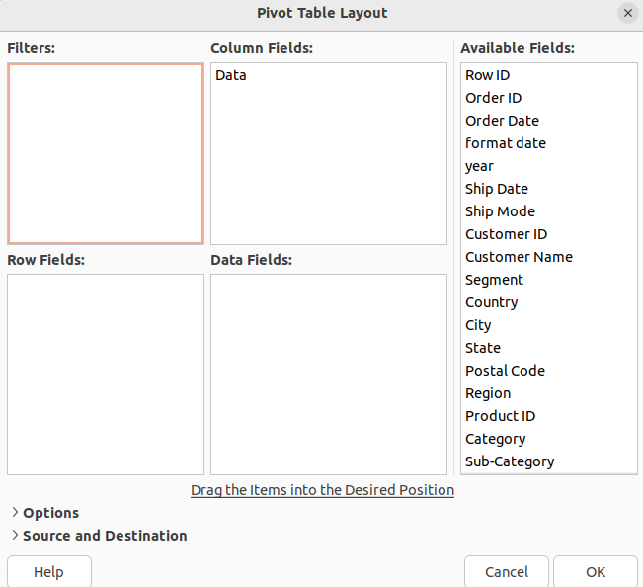

  - Drag category into row fileds and sales into data fileds then click on ok
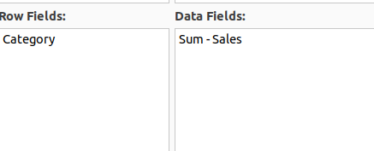
  - It will be display like this
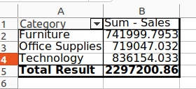

  - Go to insert >chart>pie>3D look creat tittle name “sales by catogory”

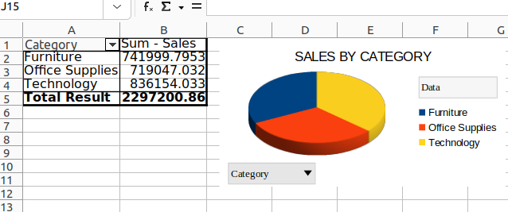
- Which sub-category has the highest sales
Drag sub-category into row fileds and sales into data fileds then click on ok
Go to insert >chart>bar chart>3D look creat tittle name “sales by sub-catogory”

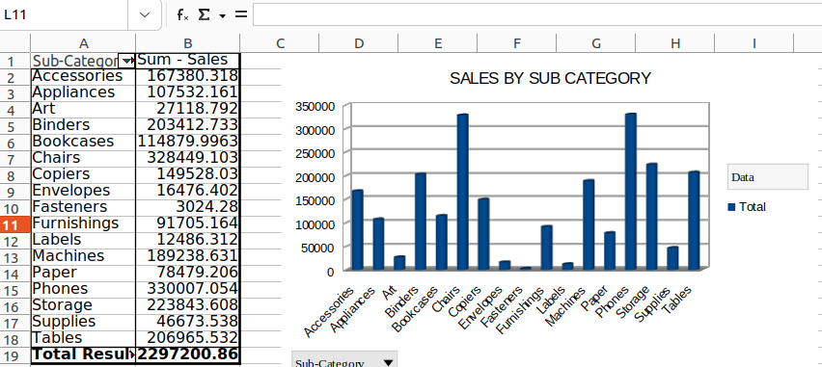

Which region drives the most sales to this super store.
Drag region into row fileds and sales into data fileds then click on ok
Go to insert >chart>bar chart>3D look creat tittle name “sales by region”

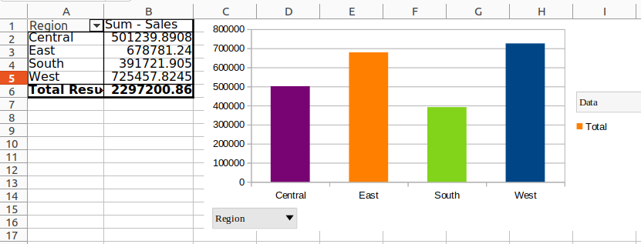

.

Experiment-8
AIM: Implement one of the following case studies using big data analytics:
a) Healthcare Data b) Web Clickstream Data
c) Social Media Data d) Educational Data
Require Software& Tools: Tableau Public
Procedure: step:-1
- Open tableau public and insert the exel sheet data (pateint_blood_test)
- Create new sheet and rename as patient count ,set the font style,size,color
- Drag sheet1(count) to rows then select text table
- Right click on count(50) format select worksheet -> change font color and size
Then go to allignment -> pane-> center
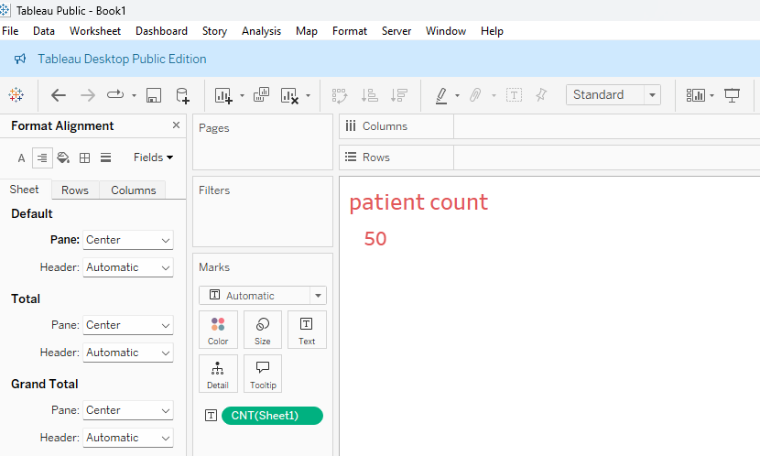
step:-2
- Duplicat patient count and rename avarage age
- Remove previous sheet count by draging left side of the screen
- Drag age to rows and convert SUM( age) to AVG(age)
- Right click on avarage age format select worksheet -> change font color and size
Then go to allignment -> pane-> center

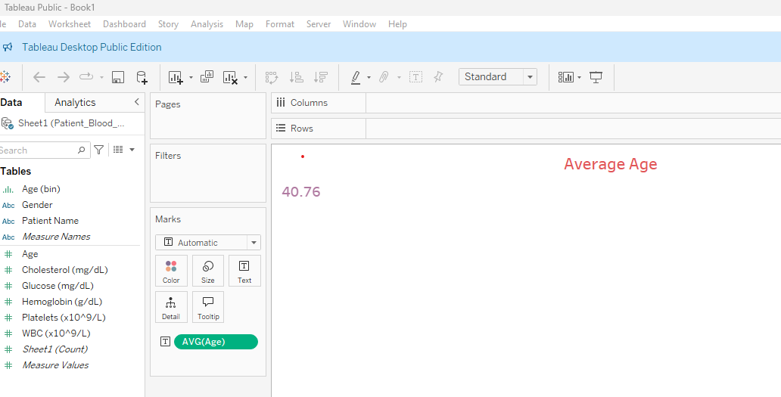
STEP 3:
- Duplicat average age and rename avarage Hemoglobin
- Remove previous sheet average age by draging left side of the screen
- Drag age to rows and convert SUM( Hemoglobin) to AVG(Hemoglobin)
- Right click on avarage Hemoglobin format select worksheet -> change font color and size Then go to allignment -> pane-> center

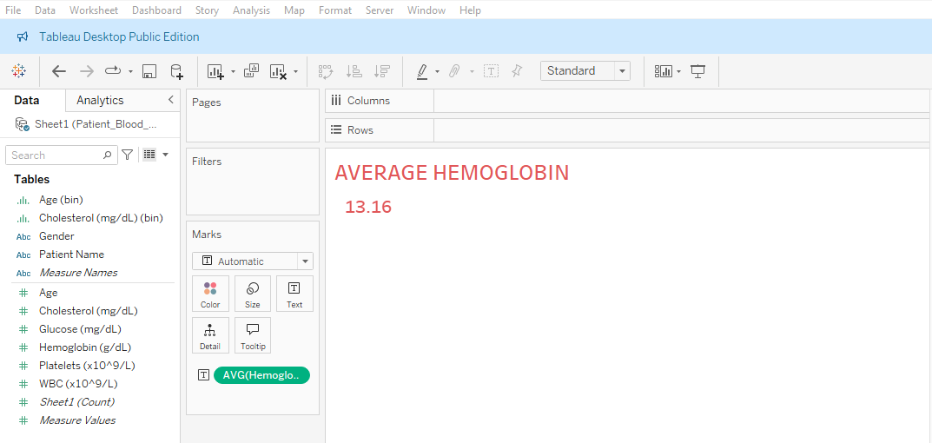

Step:-4
- Duplicate average Hemoglobin and rename average Glucose
- Remove previous sheet average Hemoglobin by draging left side of the screen
- Drag age to rows and convert SUM( Glucose) to AVG(Glucose)
- Right click on avarage Glucose format select worksheet -> change font color and size Then go to allignment -> pane-> center

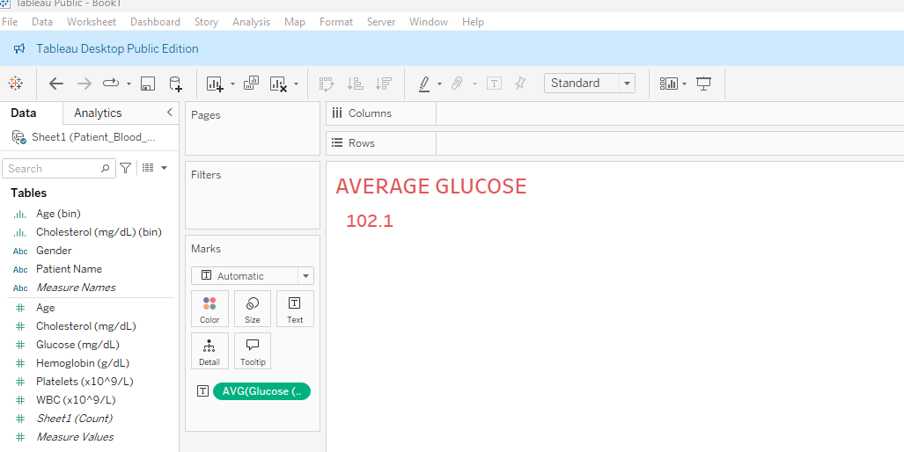

Step:-5
- Click on dash board symbol.
- Click on objects->Text and type Patient blood test analysis dash board.
- Right Click on patient blood test analysis dash board ->size-> change maximum size to 950px
- Drag from sheets paitent count,average age, average hemoglobin,average Glucose .
- Select patient count window and right click and select fit-> fit width
- Select Average age window and right click and select fit-> fit width
- Select Average Hemoglobin window and right click and select fit-> fit width
- Select Average Glucose window and right click and select fit-> fit width

Step:6

- Select new sheet and name it as count of patient by gender
- Drag Gender to columns and Sheet1(count) to rows
- Select pie chart
- To label the pie chart drag gender to label and sheet1 (count) to label.
- Go to dash board and from sheets drag patient by gender to the down of the
Patient count.

Step 7:- Select new sheet and name it as Age Distribution.
- Drag Age to columns and Sheet1(count) to rows
- And select histogram
- Left hand side table click on Age(bin)->edit-> change the bin size to 10.
- Go to dash board and from sheets drag Age distribution to the down of the
Avg age.

Step 8:- Select new sheet and name it as WBC VS PATELETS
- Drag platelets to columns and WBC to rows or vice versa
- Select Scatter plots
- Go to Analysis on menu bar-->Aggregate measures
- Go to Analysis on menu bar-->trend lines-->show trend lines
- Go to dash board and from sheets drag WBC VS PATELETS to the down of the avg hemoglobin.

Step 9:- Select age distribution sheet and rename it as cholesterol insights
- Drag cholesterol to columns

- Select histogram and click on swap rows and column symbol
Go to dash board and from sheets drag cholesterol insights to the down of the avg glucose.

Out put:

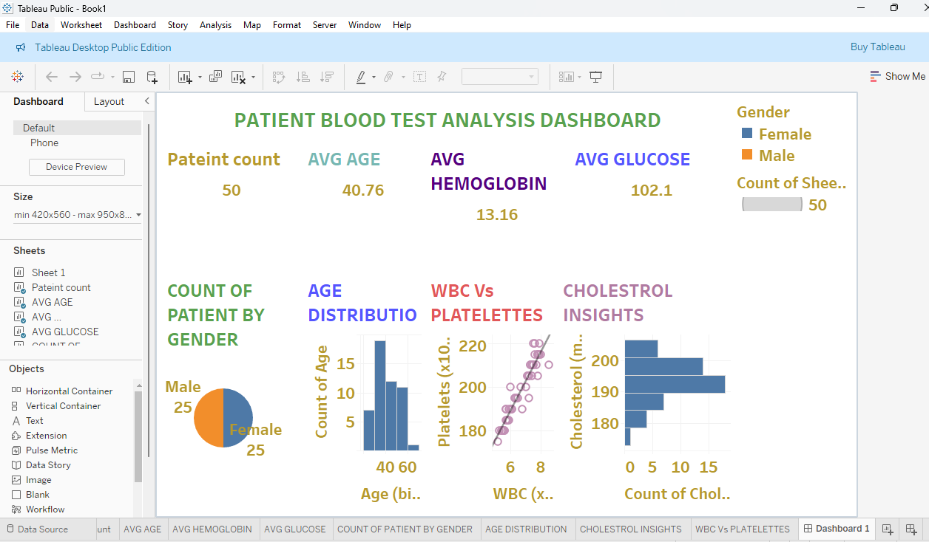

Experiment-9
AIM: Extract Sample document and apply following document preprocessing methods:
Tokenization, POS Tagging, stop words removal, Stemming and Lemmatization.

Require Software& Tools: Hadoop in Ubuntu, VM ware work station,Power Pivot(Excel)

PROCEDURE:
To implement a Python program that reads text from a file and applies the following
preprocessing techniques:
- Tokenization
- POS Tagging
- Stop Words Removal
- Stemming
- Lemmatization

In Natural Language Processing (NLP), text preprocessing is an essential step that ensures raw data is prepared for analysis. The steps involved are:
- Tokenization: Breaking the text into smaller meaningful units such as words or sentences.
- POS Tagging: Identifying the part of speech (e.g., noun, verb, adjective) for each token in the text.
- Stop Words Removal: Removing common words (e.g., is, the, and) that are not significant for the analysis.
- Stemming: Reducing words to their root form (e.g., running → run).
- Lemmatization: Converting words to their dictionary form (e.g., better → good), considering grammar and context.
Process
- Step 1: Install and import the required libraries (nltk, python-docx).
- Step 2: Define a function to read text from a .docx file.
- Step 3: Apply tokenization to the text.
- Step 4: Perform POS tagging on the tokens.
- Step 5: Remove stop words using NLTK's predefined stop words list.
- Step 6: Apply stemming using the Porter Stemmer algorithm.
- Step 7: Apply lemmatization using WordNet Lemmatizer.
- Step 8: Print the results for each preprocessing step.

Code:
- 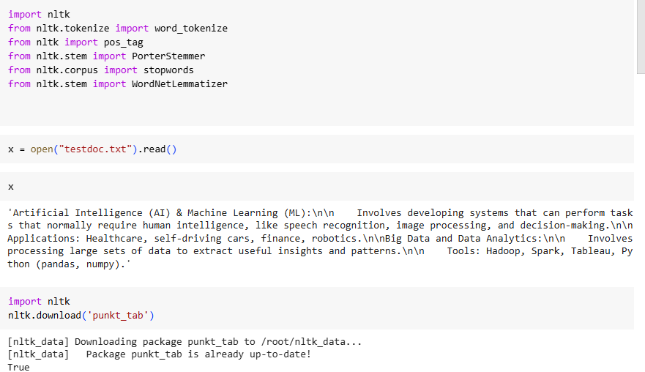
- #Tokenization
- tokens = word_tokenize(x)
- print(tokens)

- 'Artificial', 'Intelligence', '(', 'AI', ')', '&', 'Machine', 'Learning', '(', 'ML', ')', ':', 'Involves', 'developing', 'systems', 'that', 'can', 'perform', 'tasks', 'that', 'normally', 'require', 'human', 'intelligence', ',', 'like', 'speech', 'recognition', ',', 'image', 'processing', ',', 'and', 'decision-making', '.', 'Applications', ':', 'Healthcare', ',', 'self-driving', 'cars', ',', 'finance', ',', 'robotics', '.', 'Big', 'Data', 'and', 'Data', 'Analytics', ':', 'Involves', 'processing', 'large', 'sets', 'of', 'data', 'to', 'extract', 'useful', 'insights', 'and', 'patterns', '.', 'Tools', ':', 'Hadoop', ',', 'Spark', ',', 'Tableau', ',', 'Python', '(', 'pandas', ',', 'numpy', ')', '.']

- import nltk
- nltk.download('averaged_perceptron_tagger_eng')
- [nltk_data] Downloading package averaged_perceptron_tagger_eng to
- [nltk_data] /root/nltk_data...
- [nltk_data] Package averaged_perceptron_tagger_eng is already up-to-
- [nltk_data] date!
- True
- #POS Tagging
- postags = pos_tag(tokens)
- print(postags)
- [('Artificial', 'JJ'), ('Intelligence', 'NNP'), ('(', '('), ('AI', 'NNP'), (')', ')'), ('&', 'CC'), ('Machine', 'NNP'), ('Learning', 'NNP'), ('(', '('), ('ML', 'NNP'), (')', ')'), (':', ':'), ('Involves', 'VBZ'), ('developing', 'VBG'), ('systems', 'NNS'), ('that', 'WDT'), ('can', 'MD'), ('perform', 'VB'), ('tasks', 'NNS'), ('that', 'WDT'), ('normally', 'RB'), ('require', 'VBP'), ('human', 'JJ'), ('intelligence', 'NN'), (',', ','), ('like', 'IN'), ('speech', 'NN'), ('recognition', 'NN'), (',', ','), ('image', 'NN'), ('processing', 'NN'), (',', ','), ('and', 'CC'), ('decision-making', 'NN'), ('.', '.'), ('Applications', 'NNS'), (':', ':'), ('Healthcare', 'NNP'), (',', ','), ('self-driving', 'JJ'), ('cars', 'NNS'), (',', ','), ('finance', 'NN'), (',', ','), ('robotics', 'NNS'), ('.', '.'), ('Big', 'NNP'), ('Data', 'NNP'), ('and', 'CC'), ('Data', 'NNP'), ('Analytics', 'NNS'), (':', ':'), ('Involves', 'VBZ'), ('processing', 'VBG'), ('large', 'JJ'), ('sets', 'NNS'), ('of', 'IN'), ('data', 'NNS'), ('to', 'TO'), ('extract', 'VB'), ('useful', 'JJ'), ('insights', 'NNS'), ('and', 'CC'), ('patterns', 'NNS'), ('.', '.'), ('Tools', 'NNS'), (':', ':'), ('Hadoop', 'NNP'), (',', ','), ('Spark', 'NNP'), (',', ','), ('Tableau', 'NNP'), (',', ','), ('Python', 'NNP'), ('(', '('), ('pandas', 'NN'), (',', ','), ('numpy', 'RB'), (')', ')'), ('.', '.')]
- #Removing stop words
- stop_words = set(stopwords.words('english'))
- print(stop_words)

- {'when', 'your', "doesn't", 'at', 'mustn', 'until', 'these', 'own', "that'll", 'for', 'isn', 'what', 'nor', 'how', 'did', 's', "you're", 'yourselves', 'wouldn', 'same', 'those', 'below', 'about', "they're", 'but', 'only', 'was', "needn't", 'will', 'so', 'weren', 'by', 'to', 'been', 'on', 'further', 'her', 'against', "shouldn't", 't', 'while', 'after', 'do', 'didn', 'again', 'being', 'ma', "you've", 'can', 'i', 'such', 'o', 'who', "they'll", 'his', 'does', 've', 'here', 'theirs', "don't", 'very', 'other', "wasn't", "we've", 'haven', "shan't", "haven't", "i'd", "hasn't", 'doesn', 'out', 'yours', 'because', 'that', "isn'
- li = []
- for words in tokens:
- if words not in stop_words:
- li.append(words)
- print(li)

- 'Artificial', 'Intelligence', '(', 'AI', ')', '&', 'Machine', 'Learning', '(', 'ML', ')', ':', 'Involves', 'developing', 'systems', 'perform', 'tasks', 'normally', 'require', 'human', 'intelligence', ',', 'like', 'speech', 'recognition', ',', 'image', 'processing', ',', 'decision-making', '.', 'Applications', ':', 'Healthcare', ',', 'self-driving', 'cars', ',', 'finance', ',', 'robotics', '.', 'Big', 'Data', 'Data', 'Analytics', ':', 'Involves', 'processing', 'large', 'sets', 'data', 'extract', 'useful', 'insights', 'patterns', '.', 'Tools', ':', 'Hadoop', ',', 'Spark', ',', 'Tableau', ',', 'Python', '(', 'pandas', ',', 'numpy', ')', '.']

- 0s
- #Stemming
- ps = PorterStemmer()
- stemlist = []
- for words in li:
- stemlist.append([words, ps.stem(words)])
- print(stemlist)
- ['Artificial', 'artifici'], ['Intelligence', 'intellig'], ['(', '('], ['AI', 'ai'], [')', ')'], ['&', '&'], ['Machine', 'machin'], ['Learning', 'learn'], ['(', '('], ['ML', 'ml'], [')', ')'], [':', ':'], ['Involves', 'involv'], ['developing', 'develop'], ['systems', 'system'], ['perform', 'perform'], ['tasks', 'task'], ['normally', 'normal'], ['require', 'requir'], ['human', 'human'], ['intelligence', 'intellig'], [',', ','], ['like', 'like'], ['speech', 'speech'], ['recognition', 'recognit'], [',', ','], ['image', 'imag'], ['processing', 'process'], [',', ','], ['decision-making', 'decision-mak'], ['.', '.'], ['Applications', 'applic'], [':', ':'], ['Healthcare', 'healthcar'], [',', ','], ['self-driving', 'self-driv'], ['cars', 'car'], [',', ','], ['finance
- #Lemmatization
- wl = WordNetLemmatizer()
- lemilist = []
- for words in li:
- lemilist.append([words, wl.lemmatize(words)])
- print(lemilist)

- ['Artificial', 'Artificial'], ['Intelligence', 'Intelligence'], ['(', '('], ['AI', 'AI'], [')', ')'], ['&', '&'], ['Machine', 'Machine'], ['Learning', 'Learning'], ['(', '('], ['ML', 'ML'], [')', ')'], [':', ':'], ['Involves', 'Involves'], ['developing', 'developing'], ['systems', 'system'], ['perform', 'perform'], ['tasks', 'task'], ['normally', 'normally'], ['require', 'require'], ['human', 'human'], ['intelligence', 'intelligence'], [',', ','], ['like', 'like'], ['speech', 'speech'], ['recognition', 'recognition'], [',', ','], ['image', 'image'], ['processing', 'processing'], [',', ','], ['decision-making', 'decision-making'], ['.', '.'], ['Applications', 'Applications'], [':', ':'], ['Healthcare', 'Healthcare'], [',', ','], ['self-driving', 'self-driving'], ['cars', 'car'], [',', ','], ['finance', 'finance'], [',', ','], ['robotics', 'robotics'], ['.', '.'], ['Big', 'Big'], ['Data', 'Data'], ['Data', 'Data'], ['Analytics', 'Analytics'], [':', ':'], ['Involves', 'Involves'], ['processing', 'processing'], ['large', 'large'], ['sets', 'set'], ['data', 'data'], ['extract', 'extract'], ['useful', 'useful'], ['insights', 'insight'], ['patterns', 'pattern'], ['.', '.'], ['Tools', 'Tools'], [':', ':'], ['Hadoop', 'Hadoop'], [',', ','], ['Spark', 'Spark'], [',', ','], ['Tableau', 'Tableau'], [',', ','], ['Python', 'Python'], ['(', '('], ['pandas', 'panda'], [',', ','], ['numpy', 'numpy'], [')', ')'], ['.', '.']]

Experiment-10
AIM: Create representation of document by calculating Term Frequency and Inverse Document Frequency.

Require Software& Tools: Hadoop in Ubuntu, VM ware work station,Power Pivot(Excel)

PROCEDURE:
[10 .Create representation of document by calculating Term Frequency and Inverse Document Frequency.
Term Frequency-Inverse Document Frequency (TF-IDF) is a statistical measure used to evaluate the importance of a word in a document relative to a collection (or corpus) of documents. The formula for calculating TF-IDF is:
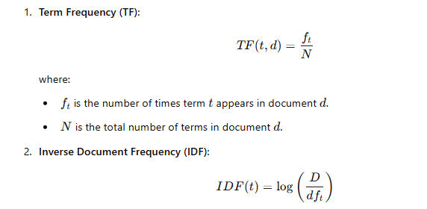
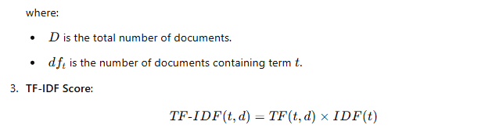

from sklearn.feature_extraction.text import TfidfVectorizer

def compute_tfidf_from_file(file_path):
# Open and read the file
with open(file_path, 'r') as file:
documents = file.readlines()

# Create TF-IDF vectorizer and compute TF-IDF matrix
vectorizer = TfidfVectorizer()
tfidf_matrix = vectorizer.fit_transform(documents)
feature_names = vectorizer.get_feature_names_out()

# Print out the TF-IDF score for each word in each document
for i, doc in enumerate(documents):
print(f"Document {i + 1} TF-IDF scores:")
for word, score in zip(feature_names, tfidf_matrix[i].toarray()[0]):
if score > 0: # Only print words with a non-zero score
print(f" {word}: {score:.4f}")
print("\n")

# Example usage
file_path = "doc.txt" # Replace this with the path to your text file
compute_tfidf_from_file(file_path)

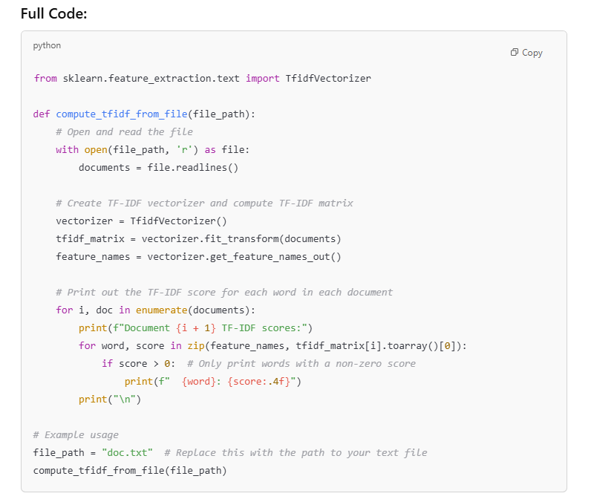
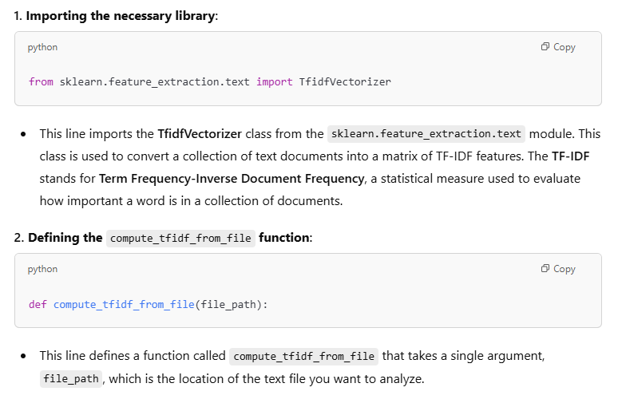
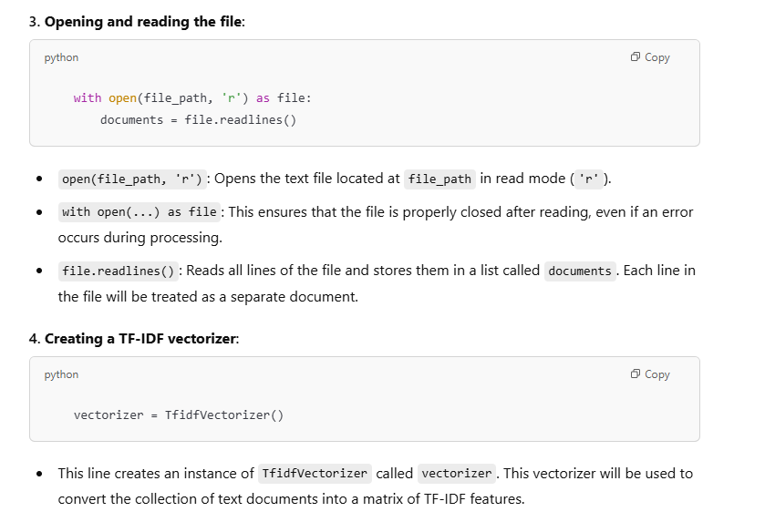
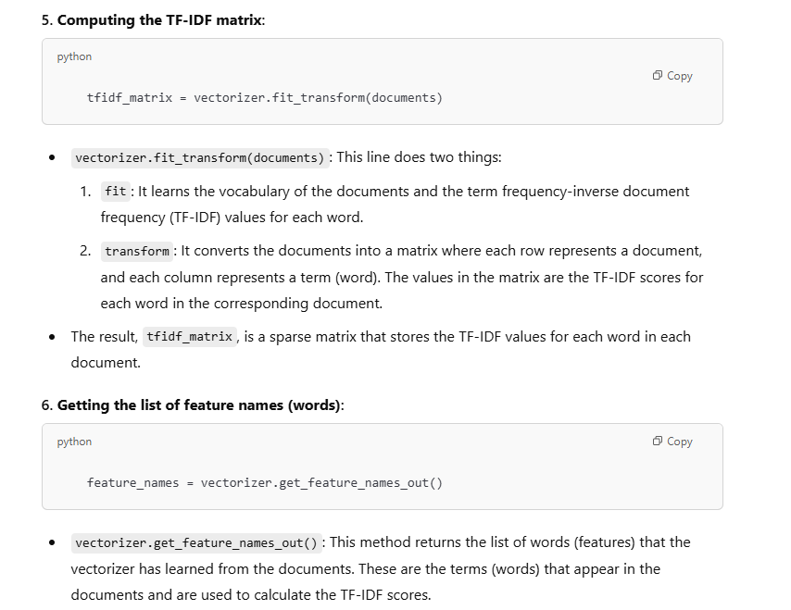
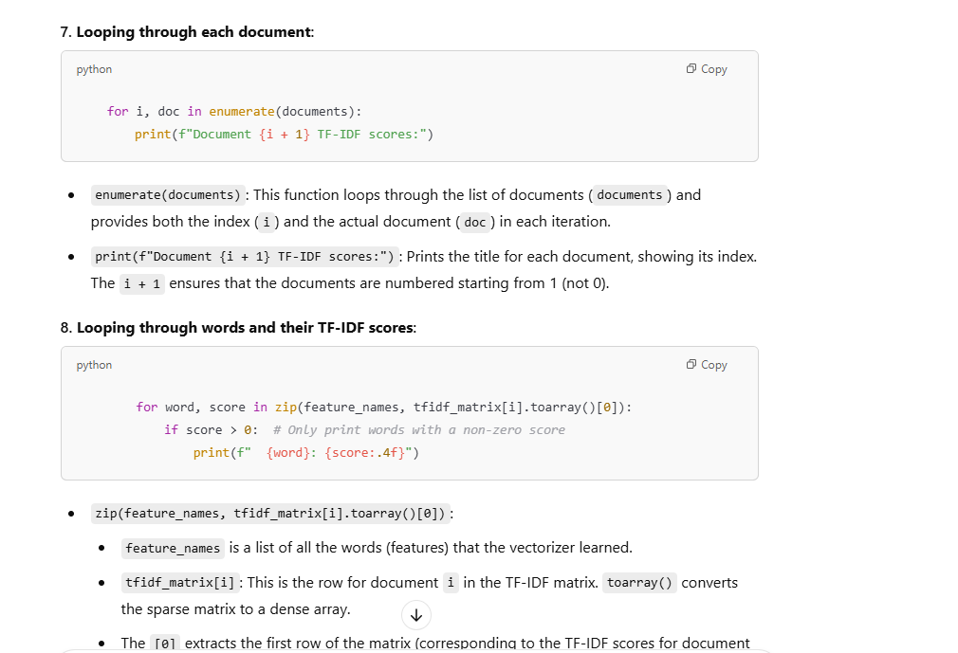
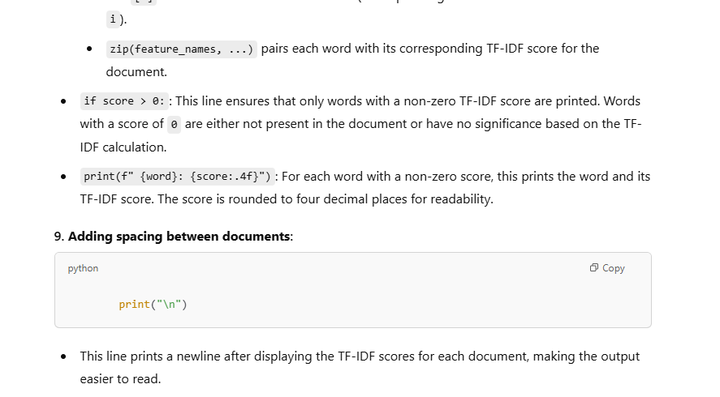
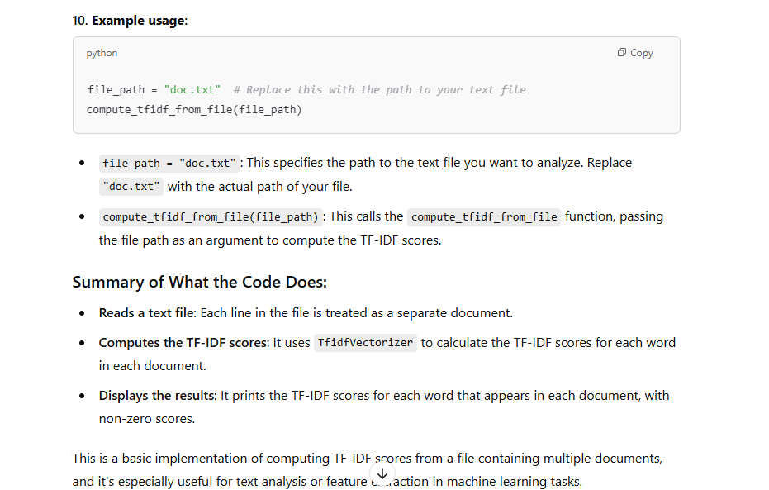
input
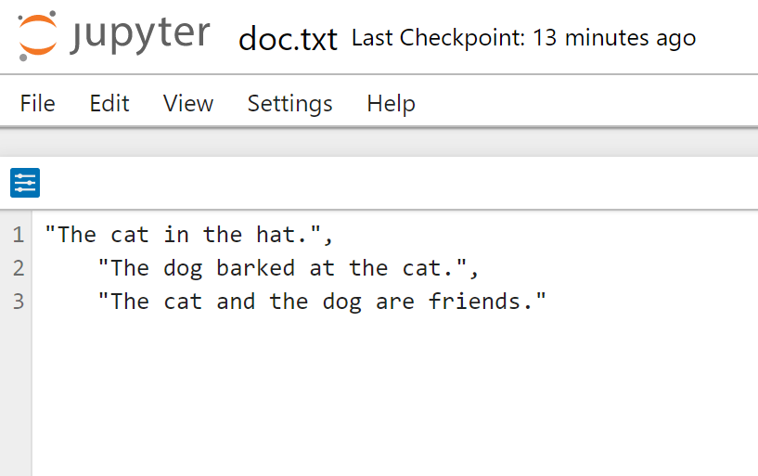

Output:
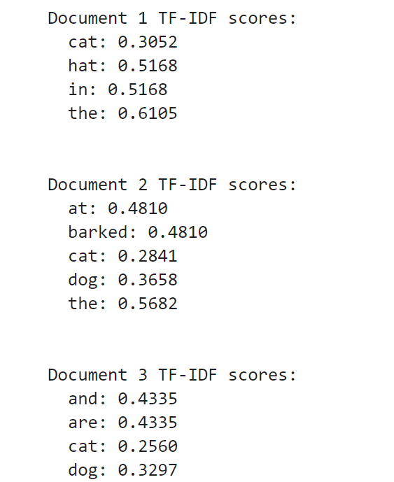

Experiment-11
AIM: Use the inbuilt dataset 'titanic' (Use the Seaborn library). Write a code to check how the price of the ticket (column name: 'fare') for each passenger is distributed by plotting a histogram
To visualize the distribution of ticket fares for passengers aboard the Titanic using a histogram.

Require Software& Tools: Anaconda(jupyternotebook)

PROCEDURE:
- Import necessary libraries:
  - Import seaborn (for loading the Titanic dataset and plotting) and matplotlib.pyplot (for customizing the plot and displaying it).
- Load the Titanic dataset:
  - Seaborn provides an inbuilt Titanic dataset, which contains information about passengers such as age, class, fare, and survival status. We'll use this dataset to explore the fare distribution.
- Preview the data:
  - Use the head() function to check the first few rows of the dataset. This helps ensure that the data is loaded correctly and gives an overview of the available columns.
- Plotting the histogram:
  - We will use Seaborn's histplot() function to plot the distribution of the "fare" column. This function will create a histogram and optionally include a Kernel Density Estimate (KDE) curve to visualize the data distribution.
- Customize the plot:
  - Add a title, x-axis label, and y-axis label to make the plot informative.
- Display the plot:
  - Use plt.show() to display the generated histogram.

- Import necessary libraries:
  - Import seaborn (for loading the Titanic dataset and plotting) and matplotlib.pyplot (for customizing the plot and displaying it).
- Load the Titanic dataset:
  - Seaborn provides an inbuilt Titanic dataset, which contains information about passengers such as age, class, fare, and survival status. We'll use this dataset to explore the fare distribution.
- Preview the data:
  - Use the head() function to check the first few rows of the dataset. This helps ensure that the data is loaded correctly and gives an overview of the available columns.
- Plotting the histogram:
  - We will use Seaborn's histplot() function to plot the distribution of the "fare" column. This function will create a histogram and optionally include a Kernel Density Estimate (KDE) curve to visualize the data distribution.
- Customize the plot:
  - Add a title, x-axis label, and y-axis label to make the plot informative.
- Display the plot:
  - Use plt.show() to display the generated histogram.

SOURCE CODE AND OUTPUT:
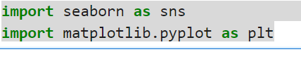
titanic=sns.load_dataset('titanic')
print(titanic.head())
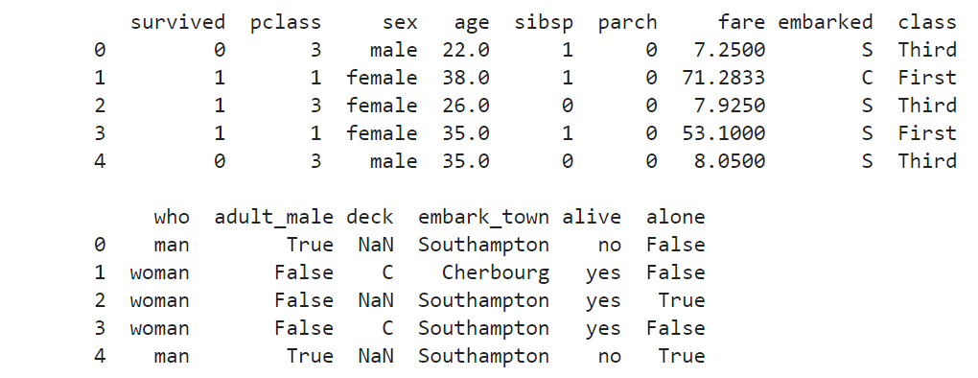

plt.figure(figsize=(8,6))
sns.histplot(titanic['fare'],kde=True,bins=30,color='blue')
plt.title('Distribution of Fare Prices',fontsize=16)
plt.xlabel("Fare Price",fontsize=10)
plt.ylabel('Frequency',fontsize=14)
plt.show()
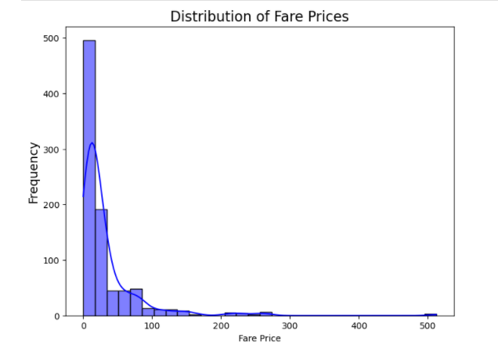

EXPERIMENT-12:
Aim:Use R-Project to carry out statistical analysis of big data
PROCEDURE:
Installation of R and Rstudio
Step 1: sudo apt-get update
sudo apt-get install r-base
Step 2: Installation of R studio
Step 3: step 1 download R studio for Ubuntu
Step 4: step2:sudo dpkg -i rstudio-2022.07.2-576-amd64 . deb
Step 5: step 3 :sudo apt install –f
Step 6: Open rstudio
Step 7: procedure:-->install.packages("gapminder")-->library(gapminder)
Step 8: >data(gapminder)
Step 9:boxplot(lifeExp)
Source Code:
# Install necessary packages
install.packages(c("dplyr", "ggplot2", "gapminder"))
library(dplyr)
library(ggplot2)
library(gapminder)

#Load the Gapminder Dataset
data(gapminder)
head(gapminder) # View the first few rows

# Exploring the Data
summary(gapminder)

# Filter for the year 2007 (the most recent in the dataset)
gapminder_2007 <- filter(gapminder, year == 2007)

# View the data for 2007
head(gapminder_2007)

#Statistical Analysis
#Average Life Expectancy by Continent

life_expectancy_by_continent <- gapminder %>%
group_by(continent) %>%
summarize(avg_lifeExp = mean(lifeExp, na.rm = TRUE))

print(life_expectancy_by_continent)
# GDP and Life Expectancy Correlation
cor(gapminder$gdpPercap, gapminder$lifeExp, use = "complete.obs")
#Linear Regression (Life Expectancy ~ GDP)
model <- lm(lifeExp ~ gdpPercap, data = gapminder)
summary(model)
#Visualization

#GDP vs. Life Expectancy
ggplot(gapminder, aes(x = gdpPercap, y = lifeExp)) +
geom_point(aes(color = continent), alpha = 0.7) +
scale_x_log10() +
labs(title = "GDP vs Life Expectancy") +
theme_minimal()

#Life Expectancy Over Time (by Continent)
ggplot(gapminder, aes(x = year, y = lifeExp, color = continent)) +
geom_line() +
labs(title = "Life Expectancy Over Time") +
theme_minimal()
#GDP vs. Population (2007)
gapminder_2007 <- filter(gapminder, year == 2007)
ggplot(gapminder_2007, aes(x = gdpPercap, y = pop)) +
geom_point(aes(color = continent), alpha = 0.7) +
scale_x_log10() + scale_y_log10() +
labs(title = "GDP vs Population (2007)") +
theme_minimal()
Ouput:
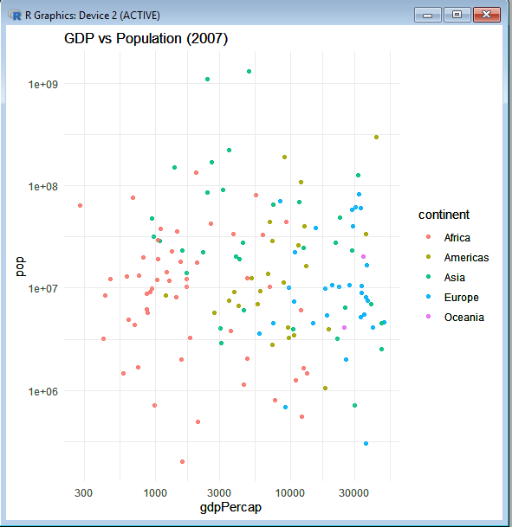

EXPERIMENT-13:
Aim: Use R-Project for data visualization of social media data.
Require Software& Tools: R studio
PROCEDURE:
library(rtweet)
# Replace with your actual Twitter API credentials
token <- create_token(
app = "MyTwitterApp",
consumer_key = "abcd1234xyz",
consumer_secret = "abcd5678xyz",
access_token = "1234-xyz5678",
access_secret = "xyz1234abcd"
)

Expected Output in R Console:
If authentication is successful, you will see something like:
<Token>
<rtweet>
app: MyTwitterApp
auth_type: oauth1.0
Checking Twitter API Rate Limits
To verify your API access, run:
rate_limit()
Expected Output:
query n remaining reset
1 search_tweets 180 179 900
2 get_timeline 900 890 900
This shows how many API requests you have left.
Fetching Tweets
Now, retrieve tweets using:
tweets <- search_tweets("#DataScience", n = 5, lang = "en", include_rts = FALSE)
head(tweets)
Expected Output in R Console:
created_at screen_name text
1 2025-03-26 12:45 DataGuy123 "I love #DataScience!"
2 2025-03-26 12:44 MLExpert99 "Machine learning is amazing!"
3 2025-03-26 12:42 AI_Fanatic "AI is the future #BigData"
This confirms that Twitter is returning real tweets.
Word Cloud Visualization:
library(wordcloud)
wordcloud(words = tweet_corpus, min.freq = 2, max.words = 100, colors = brewer.pal(8, "Dark2"))

Sentiment Analysis Bar Chart
ggplot(sentiment_df, aes(x = sentiment, y = score, fill = sentiment)) +
geom_bar(stat = "identity") +
theme_minimal() +
labs(title = "Sentiment Analysis of Tweets", x = "Sentiment", y = "Score")

